**PIZZA SALES SQL QUIRIES**

**KPI’s**

1. **Total Revenue**

**SELECT SUM(total_price) AS Total_revenue FROM pizza_sales;**

***Result***

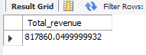

1. **Total Orders**

**SELECT COUNT(DISTINCT order_id) AS Total_orders FROM pizza_sales;**

***Result***



1. **Total Pizzas Sold**

**SELECT SUM(Quantity) AS Total_pizzas_sold FROM pizza_sales;**

***Result***

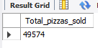

1. **Average Order Value (AOV)**

**SELECT ROUND(SUM(total_price) / COUNT(DISTINCT order_id),2) AS Average_Order_Value**

**FROM pizza_sales;**

***Result***

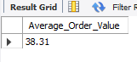

1. **Average Pizzas Price**

**SELECT ROUND(SUM(total_price) / SUM(quantity),2) AS Average_Pizzas_Price**

**FROM pizza_sales;**

***Result***



**6. Average Pizzas Per Order**

**SELECT ROUND(SUM(quantity) / COUNT(DISTINCT order_id), 2) AS avg_pizzas_per_order**

**FROM pizza_sales;**

***Result***

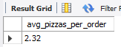

1. **Top 10 Pizzas by Revenue**

**SELECT pizza_name AS Top_pizza_name, SUM(total_price) AS Revenue FROM pizza_sales GROUP BY pizza_name ORDER BY Revenue DESC LIMIT 10;**

***Result***

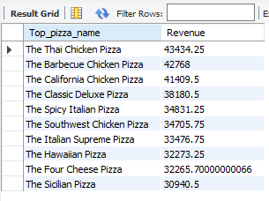

1. **Top 10 Pizzas by Quantity**

**SELECT pizza_name AS Top_pizza_name, SUM(quantity) AS Quantity FROM pizza_sales**

**GROUP BY pizza_name ORDER BY SUM(quantity) DESC LIMIT 10;**

***Result***

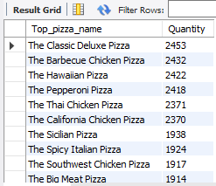

1. **Order Frequency by Hour**

**SELECT HOUR(order_time) AS order_hour, COUNT(*) AS order_count**

**FROM pizza_sales**

**GROUP BY order_hour**

**ORDER BY order_hour;**

***Result***

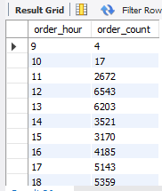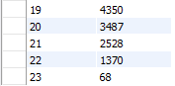

1. **Daily Trend for Total Orders**

**SELECT**

**DAYNAME(STR_TO_DATE(order_date, '%m/%d/%Y')) AS order_day,**

**COUNT(DISTINCT order_id) AS total_orders**

**FROM pizza_sales**

**WHERE STR_TO_DATE(order_date, '%m/%d/%Y') IS NOT NULL**

**GROUP BY order_day**

**ORDER BY FIELD(order_day,**

**'Monday', 'Tuesday', 'Wednesday', 'Thursday', 'Friday', 'Saturday', 'Sunday');**

***Result***

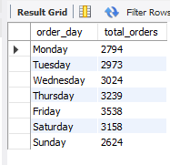

1. **Monthly Trend for Total Orders**

**SELECT**

**MONTHNAME(STR_TO_DATE(order_date, '%m/%d/%Y')) AS month_name,**

**COUNT(DISTINCT order_id) AS total_orders**

**FROM pizza_sales**

**WHERE STR_TO_DATE(order_date, '%m/%d/%Y') IS NOT NULL**

**GROUP BY month_name**

**ORDER BY FIELD(month_name,**

**'January', 'February', 'March', 'April', 'May', 'June',**

**'July', 'August', 'September', 'October', 'November', 'December');**

***Result***

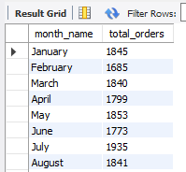 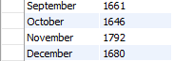

1. **% of Sales by Pizza Category**

**SELECT**

**pizza_category,**

**ROUND(SUM(total_price) / (SELECT SUM(total_price) FROM pizza_sales) * 100, 2) AS percent_of_sales**

**FROM pizza_sales**

**GROUP BY pizza_category**

**ORDER BY percent_of_sales DESC;**

***Result***

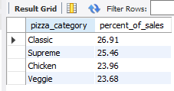

1. **% of Sales by Pizza Size**

**SELECT**

**pizza_size, ROUND(SUM(total_price),2) AS total_revenue,**

**ROUND(SUM(total_price) / (SELECT SUM(total_price) FROM pizza_sales) * 100, 2) AS percent_of_sales**

**FROM pizza_sales**

**GROUP BY pizza_size**

**ORDER BY percent_of_sales DESC;**

***Result***

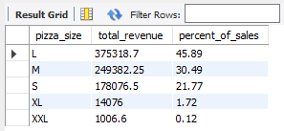

1. **Total Pizzas Sold by Pizza Category**

**SELECT**

**pizza_category, SUM(quantity) AS total_quantity_sold**

**FROM pizza_sales**

**GROUP BY pizza_category**

**ORDER BY total_quantity_sold;**

***Result***

